6.3 oxidation number
Name: ____________________ Class: ____________________ Due date:
1. The element vanadium, V, forms several oxides.
In which change is oxidation taking place? （ ）
A VO₂ → V2O₃
B V2O₅ → VO₂
C V2O₃ → VO
D V2O₃ → V2O₅

2. The equations for two reactions P and Q are given.
P 2NaNO₂ + O₂ → 2 NaNO₃
Q 2HgO → 2 Hg + O₂
In which of these reactions does oxidation of the underlined substance occur? （ ）
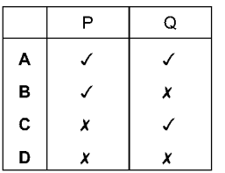

3. In which equation does the oxidation of the underlined compound occur?（ ）
A 2CuO + C → CO₂ + Cu
B Fe₂O₃ + 3CO→ 2Fe + 3CO₂
C 2Mg + O₂ → 2MgO
D MnO₂ + 4HCl → MnCl₂ + 2H₂O + Cl₂

4. In which change is N₂O₃ oxidised? （ ）
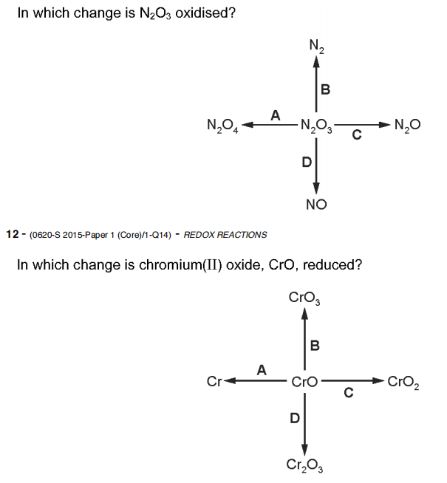
5. In which change is Chromium(ll) oxide, CrO , reduced? （ ）
6. Which change represents an oxidation reaction? （ ）
A chlorine changes to chlorate(I) ions
B chlorine changes to chloride ions
C copper(II) ions change to copper
D potassium manganate(VII) ions change to potassium manganate(VI) ions

7. Which changes represent oxidation? （ ）
1 2I⁻ → I₂ + 2e⁻
2 Cr(VI) → Cr(III)
3 Fe(II) → Fe(III)
A 1 and 2 B 1 and 3 C 1 only D 2 only

8. Which changes represent reduction? （ ）
1 Cl₂ + 2e⁻ → 2Cl⁻
2 Mn(VII) → Mn(II)
3 sulfate(IV) → sulfate(VI)
A 1 and 2 B 1 and 3 C 1 only D 2 only

9. The equations for two reactions of iodide ions are shown.
reaction 1 2 I⁻(aq) + H₂O₂(aq) → I₂(aq) + 2OH⁻(aq)
reaction 2 I⁻(aq) + Ag⁺(aq) → AgI(s)
Which statement is correct? （ ）
A Both reactions are redox reactions.
B Neither reaction is a redox reaction.
C Only reaction 1 is a redox reaction.
D Only reaction 2 is a redox reaction.

10.The equation for the reaction between zinc and aqueous copper(II) sulfate is shown.
Zn + CuSO₄ → ZnSO₄ + Cu
Which statement is correct? （ ）
A The oxidation state of the oxidising agent has changed from 0 to +2.
B The oxidation state of the reducing agent has changed from 0 to +2.
C The oxidation state of the reducing agent has changed from +2 to 0.
D This is not a redox reaction. The solution changes from colourless to blue.

11. Which reaction of hydrochloric acid is a redox reaction? （ ）
A 2Na + 2HCl → 2NaCl + H₂
B Na₂O + 2HCl → 2NaCl + H₂O
C NaOH + HCl → NaCl + H₂O
D Na₂CO₃ + 2HCl → 2NaCl + H₂O + CO₂

12. The formulae of two compounds of manganese are MnO₂ and KMnO₄.
In these two compounds the oxidation state of potassium is +1 and the oxidation state of oxygen is –2.
What are the oxidation states of manganese in each of these two compounds? （ ）
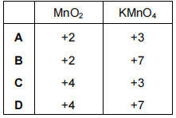

13. Which changes represent reduction? （ ）
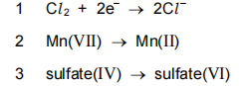
A 1 and 2 B 1 and 3 C 1 only D 2 only

14. The ionic equation for the reaction between zinc and aqueous copper ions is shown.
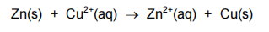
Which statement about this reaction is correct? （ ）
A Copper ions are oxidised and their oxidation state changes.
B Copper ions are reduced because they lose electrons.
C Zinc atoms are oxidised and their oxidation state changes.
D Zinc atoms are reduced because they gain electrons.

15. Which compound is written with the oxidation state (VII)? （ ）
A CuSO₄
B FeSO₄
C Fe₂(SO₄)₃
D KMnO₄

16. Iodine is extracted from seaweed using acidified hydrogen peroxide, in a redox reaction. The ionic equation for the reaction is:
2I⁻(aq) + H₂O₂(aq) + 2H⁺(aq) →I₂(aq) + 2H₂O(l)
a Give the oxidation number for iodine in seaweed.
b There is a colour change in this reaction. Why?
c i Is the iodide ion oxidised, or reduced?
ii Write the half - equation for this change.
d In hydrogen peroxide, the oxidation number for hydrogen is +I.
i What is the oxidation number of the oxygen in hydrogen peroxide?
ii How does the oxidation number for oxygen change during the reaction?
iii Copy and complete this half - equation for hydrogen peroxide:
H₂O₂(aq) + 2H⁺(aq) + →2H₂O(l)

17. Oxidation numbers in a formula add up to zero.
a Give the oxidation state of the underlined atom in each formula below:
i aluminium oxide, Al₂O₃
ii ammonia, NH₃
iii H₂CO₃ carbonic acid
iv phosphorus trichloride, PCl₃
v copper(I) chloride, CuCl
vi copper(II) chloride, CuCl₂

